CSE 5330 - 005 Database Systems Project Phase 3

Vignesh Manikandan - 1002012757

Ruban Eswaravelu – 1002018133

TABLE OF CONTENTS

|  |  |  |
| --- | --- | --- |
| **S.No** | **TITLE** | **Page No.** |
|  | Honor code | 3 |
|  | Part 1 | 5 |
|  | Part 2 | 9 |

**HONOR CODE:**

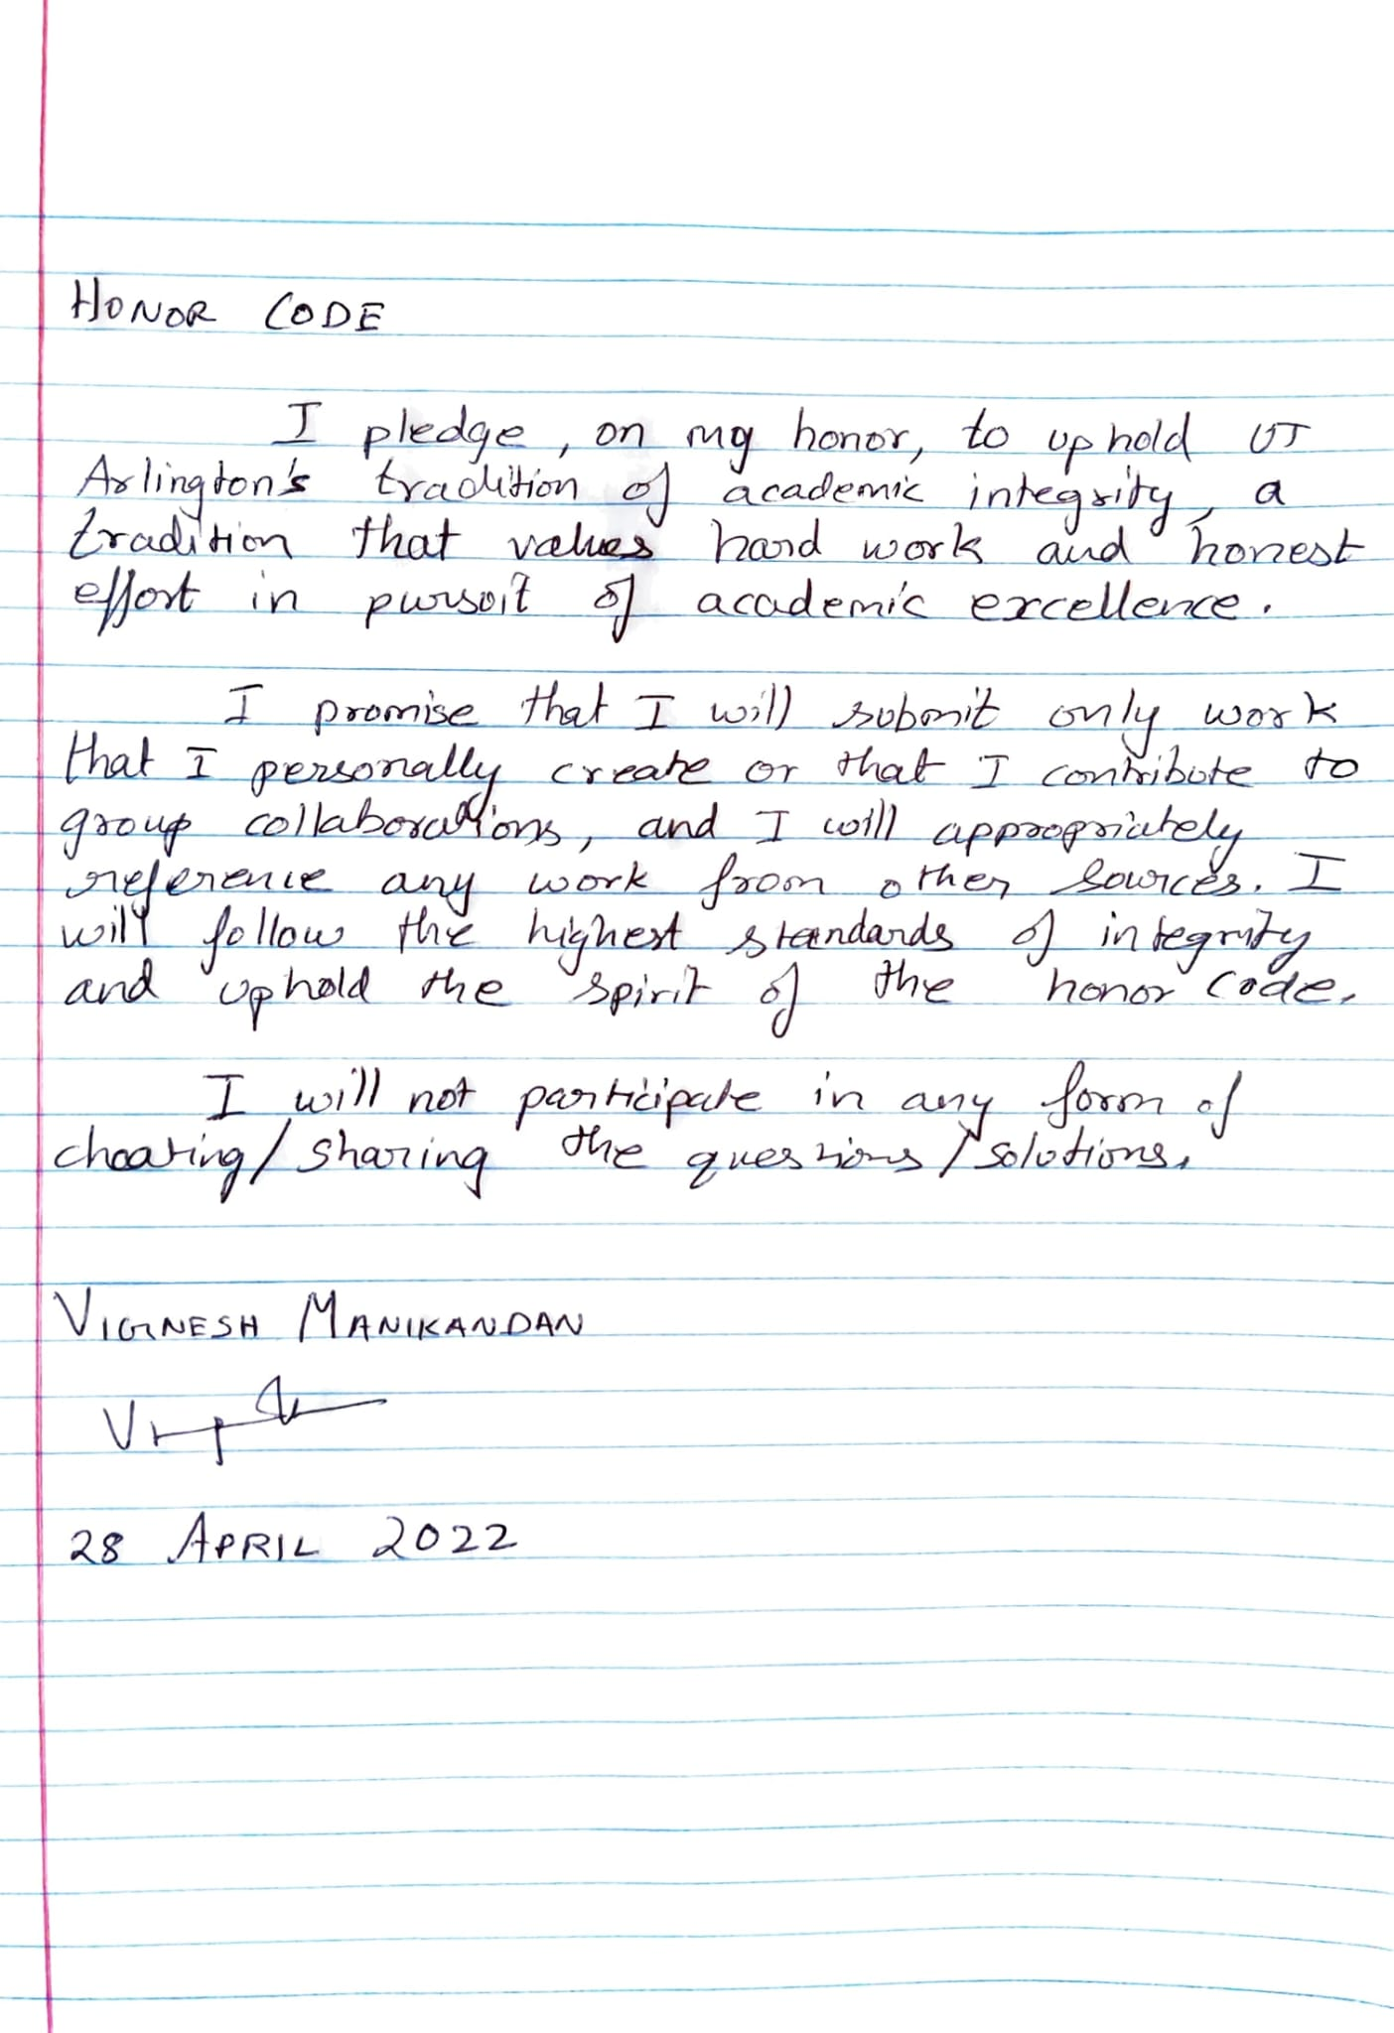

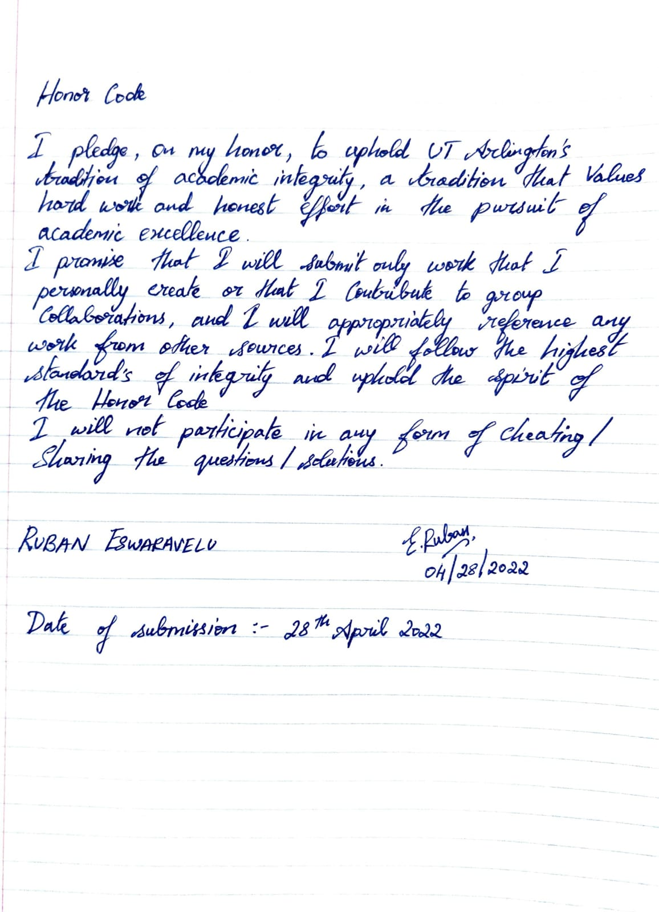

**PART-1**

1.Display the customer details based on any one of the following: state name or stateAb

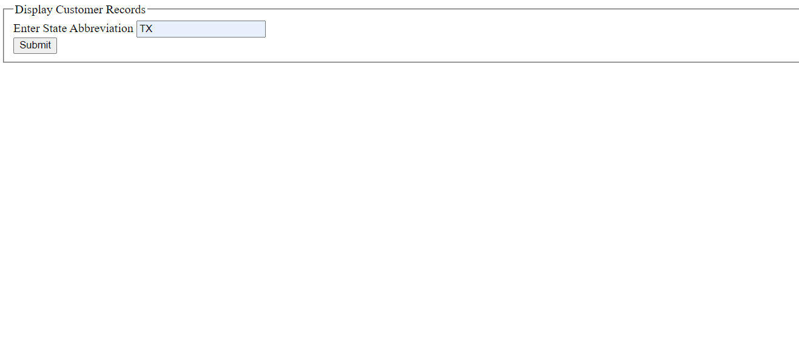

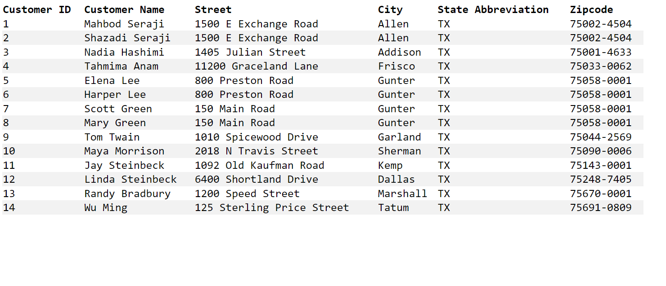

1. Insert a new state ‘Alaska’, ‘AA’ in the art gallery database using the web interface you created.

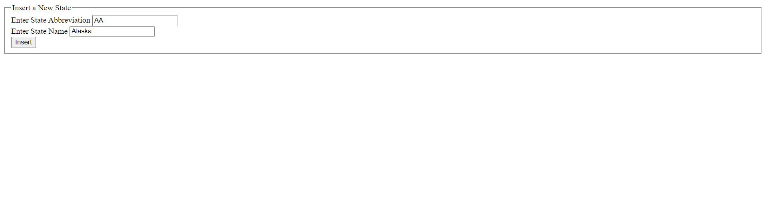

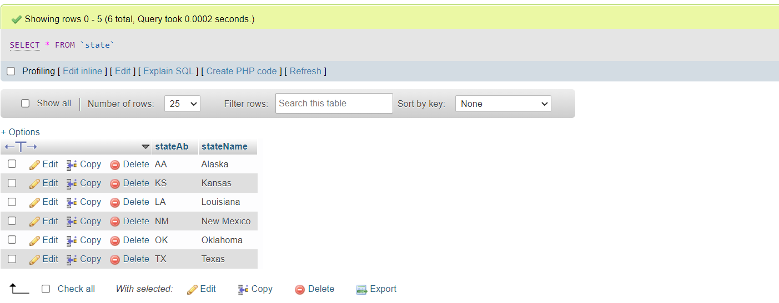

3. Update the state record that you just added to ‘Alaska’, ‘AK’ using the web interface you created.

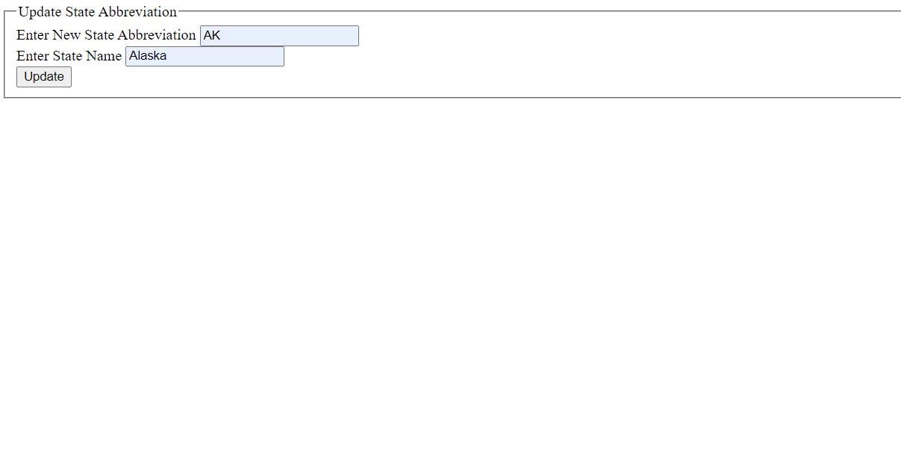

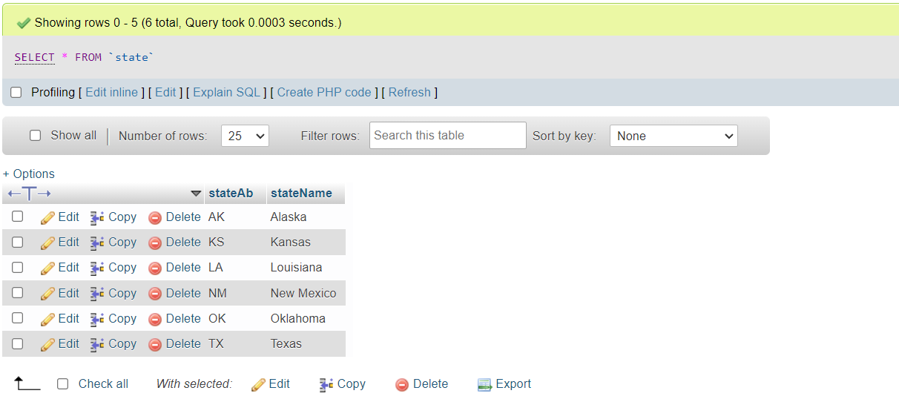

4. Delete the state of Alaska record that you just added using the web interface you created.

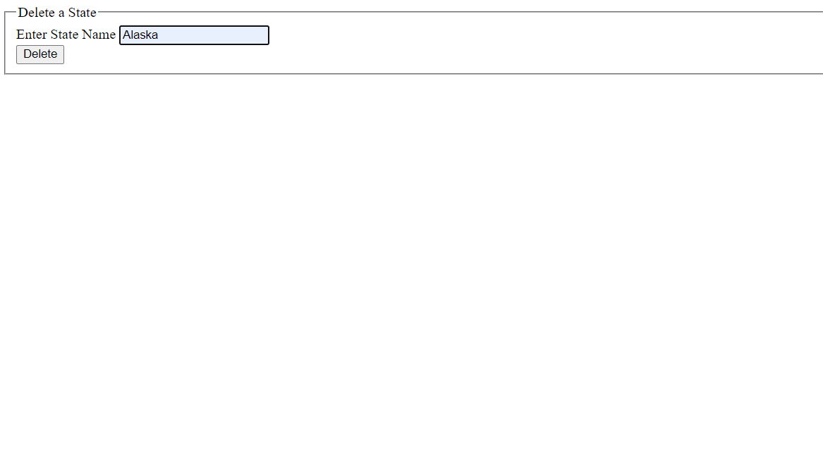

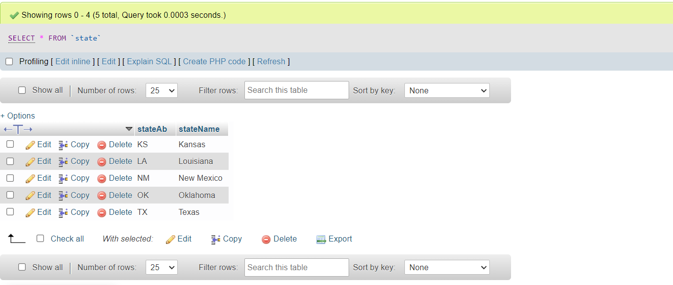

**PART-2**

1) CREATE VIEW ArtworkView AS

SELECT artist.name AS 'ArtistName', artist.birthDate AS 'Bdate', artwork.title AS 'ArtworkTitle', artwork.form AS 'Form', bought.saleDate AS 'SaleDate', artwork.price AS 'ArtworkPrice', customer.name AS 'CustomerName', payments.finalDate AS 'FinalPaymentDate', artwork.acquisitionDate AS 'AcquisitionDate' FROM artwork

JOIN artist ON artist.aID = artwork.aID

JOIN bought ON artwork.artID = bought.artID

JOIN customer ON customer.cID = bought.cID

JOIN payments on artwork.artID = payments.artID

ORDER BY artist.name;

2) SELECT DISTINCT artworkview.ArtistName, artworkview.CustomerName

FROM artworkview

WHERE artworkview.ArtistName RLIKE '^[aeiouAEIOU].*[aeiouAEIOU]' AND artworkview.CustomerName RLIKE '^[aeiouAEIOU].*[aeiouAEIOU]' ;

3) SELECT DISTINCT artworkview.ArtistName

FROM artworkview

WHERE artworkview.Form = 'painting';

4) SELECT DISTINCT artworkview.ArtistName, artworkview.ArtworkTitle, CONCAT('$', FORMAT(artworkview.ArtworkPrice, 2)) AS 'ArtworkPrice'

FROM artworkview

WHERE artworkview.ArtworkPrice BETWEEN 250 AND 15000;

5) SELECT DISTINCT artworkview.ArtistName, COUNT(artworkview.ArtistName) AS 'Artworks Sold'

FROM artworkview

GROUP BY artworkview.ArtistName;

6)

SELECT DISTINCT artist.name, artist.birthDate, artwork.title, bought.saleDate, customer.name, payments.finalDate

FROM artwork

JOIN artist ON artist.aID = artwork.aID

JOIN bought ON artwork.artID = bought.artID

JOIN customer ON customer.cID = bought.cID

JOIN payments on artwork.artID = payments.artID

WHERE artwork.acquisitionDate = '1995-09-12';

